**Heartbeat Sensor**

Heartbeat Sensor is an electronic device that is used to measure the heart rate i.e. speed of the heartbeat. Monitoring body temperature, heart rate and blood pressure are the basic things that we do in order to keep us healthy.

In order to measure the body temperature, we use thermometers and a sphygmomanometer to monitor the Arterial Pressure or Blood Pressure.

Heart Rate can be monitored in two ways: one way is to manually check the pulse either at wrists or neck and the other way is to use a Heartbeat Sensor.

In this project, we have designed a Heart Rate Monitor System using Arduino and Heartbeat Sensor. You can find the Principle of Heartbeat Sensor, working of the Heartbeat Sensor and Arduino based Heart Rate Monitoring System using a practical heartbeat Sensor.

**Introduction to Heartbeat Sensor**

Monitoring heart rate is very important for athletes, patients as it determines the condition of the heart (just heart rate). There are many ways to measure heart rate and the most precise one is using an Electrocardiography

But the more easy way to monitor the heart rate is to use a Heartbeat Sensor. It comes in different shapes and sizes and allows an instant way to measure the heartbeat.

Heartbeat Sensors are available in Wrist Watches (Smart Watches), Smart Phones, chest straps, etc. The heartbeat is measured in beats per minute or bpm, which indicates the number of times the heart is contracting or expanding in a minute.

#### Principle of Heartbeat Sensor

The principle behind the working of the Heartbeat Sensor is Photoplethysmograph. According to this principle, the changes in the volume of blood in an organ is measured by the changes in the intensity of the light passing through that organ.

Usually, the source of light in a heartbeat sensor would be an IR LED and the detector would be any Photo Detector like a Photo Diode, an LDR (Light Dependent Resistor) or a Photo Transistor.

With these two i.e. a light source and a detector, we can arrange them in two ways: A Transmissive Sensor and a Reflective Sensor.

In a Transmissive Sensor, the light source and the detector are place facing each other and the finger of the person must be placed in between the transmitter and receiver.

Reflective Sensor, on the other hand, has the light source and the detector adjacent to each other and the finger of the person must be placed in front of the sensor.

#### Working of Heartbeat Sensor

A simple Heartbeat Sensor consists of a sensor and a control circuit. The sensor part of the Heartbeat Sensor consists of an IR LED and a Photo Diode placed in a clip.

The Control Circuit consists of an Op-Amp IC and few other components that help in connecting the signal to a Microcontroller. The working of the Heartbeat Sensor can be understood better if we take a look at its circuit diagram.

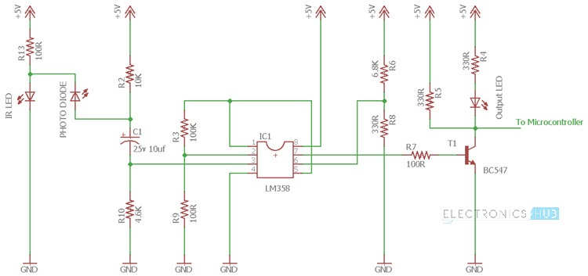

The above circuit shows the finger type heartbeat sensor, which works by detecting the pulses. Every heartbeat will alter the amount of blood in the finger and the light from the IR LED passing through the finger and thus detected by the Photo Diode will also vary.

The output of the photo diode is given to the non – inverting input of the first op – amp through a capacitor, which blocks the DC Components of the signal. The first op – amp cats as a non – inverting amplifier with an amplification factor of 1001.

The output of the first op – amp is given as one of the inputs to the second op – amp, which acts as a comparator. The output of the second op – amp triggers a transistor, from which, the signal is given to a Microcontroller like Arduino.

The Op – amp used in this circuit is LM358. It has two op – amps on the same chip. Also, the transistor used is a BC547. An LED, which is connected to transistor, will blink when the pulse is detected.

**Heartbeat Sensor Interfacing with Raspberry Pi:**

Interfacing a heartbeat sensor with the Raspberry Pi opens up a realm of possibilities for health monitoring, fitness tracking, and biometric applications. Heartbeat sensors, like pulse oximeters or ECG (Electrocardiogram) modules, can be connected to the Raspberry Pi's GPIO pins, allowing it to collect and process real-time data on a person's heart rate and related physiological parameters. This integration enables the development of innovative healthcare solutions, including remote patient monitoring, fitness wearables, and biofeedback systems. With the Raspberry Pi's computational power and Python programming capabilities, developers can process and analyze the data received from the sensor to detect irregularities, monitor trends, and generate alerts when necessary. This can be instrumental in providing timely healthcare interventions or enabling individuals to keep track of their well-being. Whether used in medical research, sports science, or personal wellness projects, the combination of a heartbeat sensor and the Raspberry Pi enhances the capacity to understand and respond to vital health information in an accessible and customizable manner.

Heartbeat sensor interfacing with the Raspberry Pi not only offers a wealth of health-related possibilities but also empowers individuals and healthcare professionals to take advantage of real-time, accurate heart rate monitoring. The Raspberry Pi's flexibility and connectivity options, coupled with a variety of heartbeat sensor choices, enable applications that range from telemedicine and stress management to sports performance optimization. Using sensors like the MAX30102 or AD8232, users can capture both pulse rate and heart rhythm data. The Raspberry Pi, equipped with its GPIO pins and robust computing capabilities, can then process this data, displaying it on a connected screen or even transmitting it over a network for remote monitoring. Additionally, data logging and analysis can provide valuable insights into long-term health trends or help diagnose heart-related conditions. The potential for combining this technology with machine learning algorithms for advanced anomaly detection further expands the horizons of what can be achieved with heartbeat sensor interfacing and Raspberry Pi, making it a versatile platform for personalized health solutions.

